Name: J Viswaksena Roll.No: AM.EN.U4AIE21035

Lab Assignment 4

Topics Covered – 802.11 Protocol, Beacon Frame, Association and Disassociation

**Q1. Identify the frequency of Beacon Frames for the two Aps.**

What are the SSIDs of the two access points that are issuing most of the beacon

frames in this trace?

**Answer:-**

Source: Cisco-Li_f7:1d:51 Destination: Broadcast Beacon frame, BI=100, **SSID="30 Munroe St"**

Source: LinksysG_67:22:94 Destination: 7f:26:ff:ff:ff:ff Beacon frame, BI=100, **SSID="linksys12"[Malformed Packet: length of contained item exceeds length of containing item]**

**Q2. What are the intervals of time between the transmissions of the beacon frames from the**

linksys_ses_24086 access point? From the 30 Munroe St. access point?

**Answer:-**

**30 Munroe St**

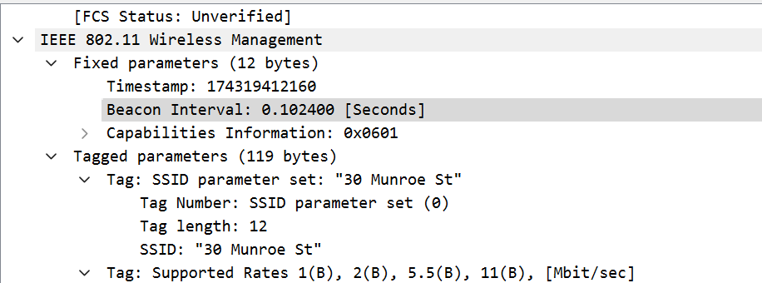

**Timestamp: 174319412160**

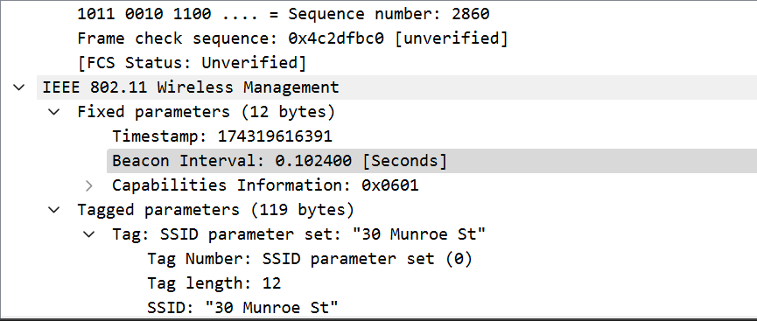

**Timestamp: 174319616391**

**Time interval: 174319616391 – 174319412160 = 204231 microseconds**

**linksys12**

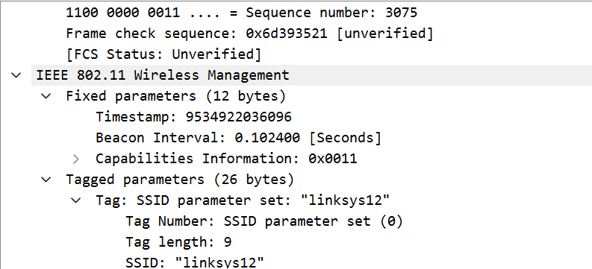

**Timestamp: 9534922036096**

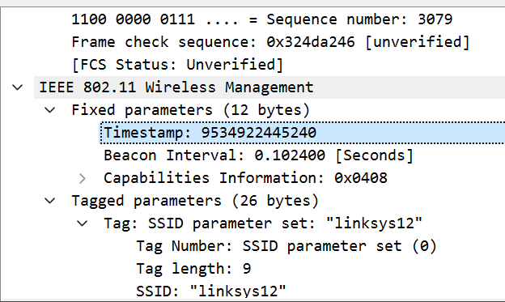

**Timestamp: 9534922445240**

**Time interval: 9534922445240 – 9534922036096 = 409144**

**Q3. What is the destination Address for Beacon Frames?**

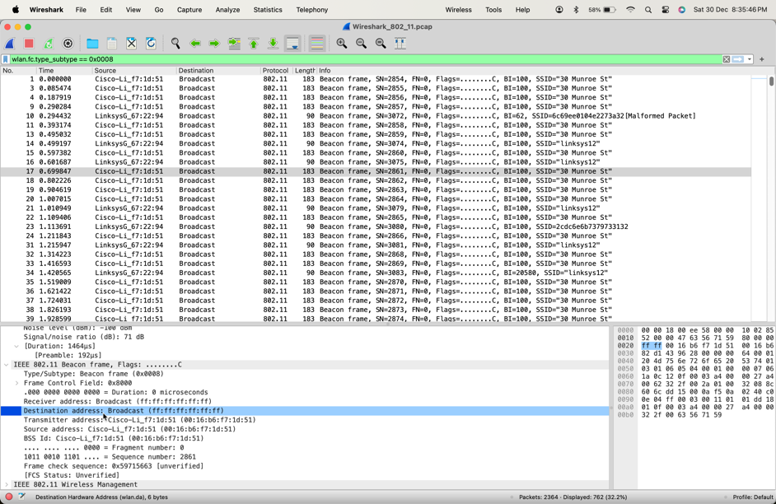

**Q4. What are the three MAC Addresses used in an Association Request?**

**Solution:**

Destination address, Transmitter address and BSS Id are the three MAC Addresses

From the previous screenshot:

Destination address: ff:ff:ff:ff:ff:ff

Transmitter address: 00:16:b6:f7:1d:51

BSS Id: 00:16:b6:f7:1d:51

**Q5. For the Second AP to which the device tries to associate, is it Active or Passive scanning?**

Solution:

Based on the destination address: **ff:ff:ff:ff:ff:ff => Passive scanning, if to a specific address => Active scanning.**

30 Munroe St: Passive scanning

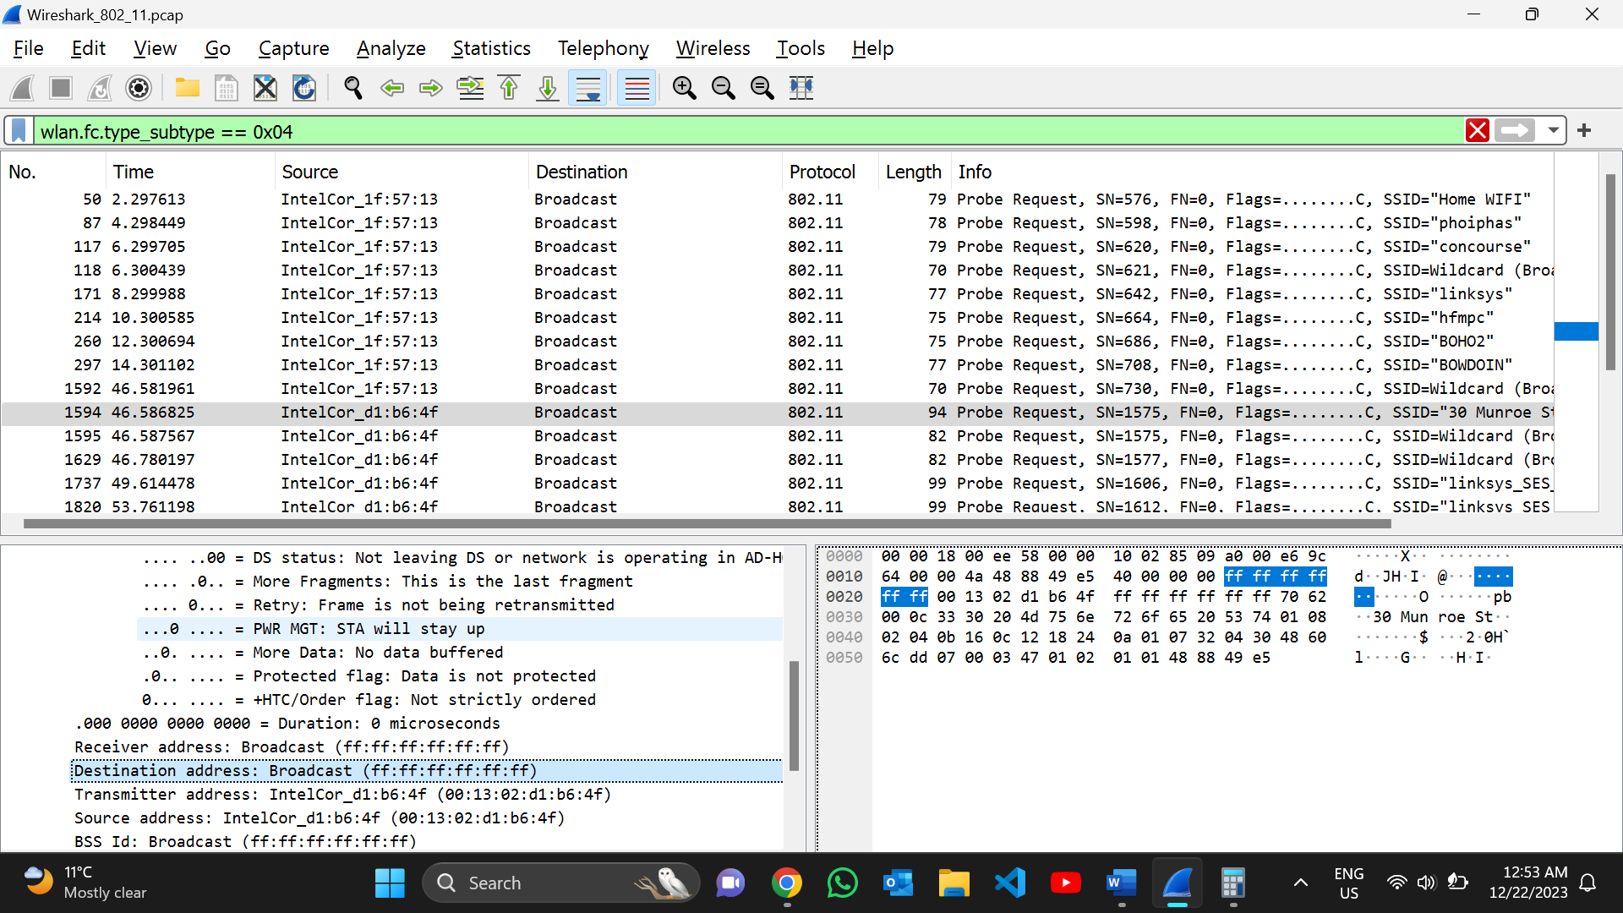

Linksys: Passive scanning

